**Automated Detection of Pubic Rami Fractures in X-ray Images Using Pretrained Convolutional Neural Networks**

**Abstract**

Pubic rami fractures are common in the elderly, often resulting from low-energy trauma, and can be very challenging to diagnose because they are subtle on X-rays. It is crucial to accurately identify this condition at the right time to prevent complications such as immobilization and chronic pain. The proposed study involves a pretrained convolutional neural network (CNN) based automated detection system for pubic rami fractures in X-ray images, which will be collected from public hospitals in Sri Lanka. The dataset, consisting of 2,000 X-ray images labeled as fractured or non-fractured, was preprocessed and augmented to improve the model's robustness. Four pretrained CNN models such as ResNet-50, ResNet-101, EfficientNet-B0, and EfficientNetV2, were fine-tuned for binary classification of pubic rami fractures. The ResNet-101 model showed the best performance, achieving an accuracy of 82%, precision of 0.84, recall of 0.82, and F1 score of 0.83, outperforming other models and even the custom CNN baseline. These results highlight the potential of pretrained CNNs to improve detection accuracy through transfer learning, especially given the scarcity of medical image data. The system could assist clinicians in early diagnosis, reduce diagnostic errors, and streamline clinical workflows. However, challenges such as unbalanced class representation and the subtlety of fracture signs remain, indicating that larger and more diverse datasets, along with more advanced augmentation methods, will be necessary in future studies.

**Key words:** Pubic rami fractures, Deep learning, X-Ray, Resnet-101, Medical imaging, Binary classification

**Introduction**

Fractures involving pubic rami, as a part of the anterior pelvic ring, is common among the older adults because of osteoporosis or low-energy trauma (Ukai et al., 2021). It is important that such fractures can cause serious morbidity, such as long-term recovery process and also result in reduced quality of life, and hence early and precise diagnosis of such fractures (Mu et al., 2021) is important. Analysis of the X-ray is usually time-consuming and prone to errors, especially in cases of small/non displaced fractures (Hsieh et al., 2023).

**Objectives**

The paper presents the research of automated detection, based on pre-trained CNN, which can provide solid feature extraction, to improve diagnostics accuracy and optimize clinical workflow. The main aim is to create an automated process of automatic detection of pubic rami fractures in X-ray images with the help of pretrained CNNs (Hsieh et al., 2023; Yıldız Potter et al., 2024). The system will continue to train small losses or set aside a portion of the data that can then be employed in training a system using transfer learning to produce high levels of accuracy with binary classification (fractured vs. non-fractured), and can be later utilized in clinical domains.

**Data**

The anteroposterior (AP) pelvic X-ray images consist of 2,000 images (Base Hospital Tellipalai Jaffna: 600 images, Northern Central Hospital Jaffna: 800 images, Teaching Hospital Batticaloa: 600 images) gathered in three hospitals in Sri Lanka in 2022-2023. Radiologists verified the fractured (900 images) and non-fractured (1,100 images) categorized images. The preprocessing steps were the conversion of images to the RGB format with the help of OpenCV and the Albumentations library, resizing to the 224x224 pixel, and normalizing with ImageNet mean ([0.485, 0.456, 0.406]) and the standard deviation of ([0.229, 0.224, 0.225]). Random rotations (+-30 degrees), horizontal flips (p=0.5), brightness/contrast, gamma correction and randomly adding Gaussian noise (p=0.3) were employed (Qi et al., 2020) in order to triple the size of the data and prevent overfitting and achieve a better generalization.

**Methodology**

We chose four pretrained CNN networks, namely, ResNet-50, ResNet-101, EfficientNet-B0, and EfficientNetV2 because they have already demonstrated their effectiveness in solving image classification problems. These pretrained models were trained using the ImageNet data, on which they had been trained with the parameter include_top=False, and used to fine-tune binary classification. A custom classification head was attached, which is composed of three layers; a GlobalAveragePooling2D, a Dense connected with 512 nodes, ReLU activation, a Dropout layer (the 0.5 probability), and a terminal Dense layer with the sigmoid activation and binary output. The data was separated through stratified sample in 70 percent as the training, and 15 percent each as the validation and testing set. The models were trained on the Adam optimizer and binary cross-entropy loss, and eventually, the base layers were frozen to utilize pretrained features.

Figure 1: Model architecture of Pubic rami fracture

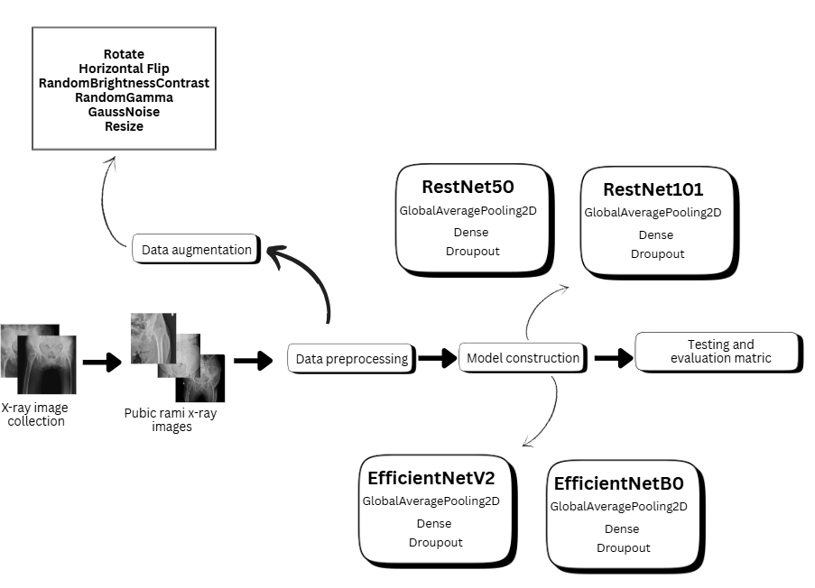

**Results and Discussion**

The best testing accuracy was found to be 82 with the precision of 0.84, the recall of 0.82 and the F1 score of 0.83 using the ResNet-101 model with training taking 1,750 seconds. ResNet-50 came next with 79 per cent accuracy, precision of 0.80, recall of 0.79 and F1 score of 0.79 (1,200 seconds). EfficientNet-B0 and EfficientNetV2 achieved an accuracy of 75 and 72 percent respectively within a training time of 250 seconds making EfficientNetV2 the fastest to train. In comparison to a baseline of custom CNN (accuracy: 68%, F1: 0.65), trained models with the help of pretrained models possessed a better generalization, which is why transfer learning was achieved. ResNets-101 has deep residual connections, which allows it to perform well on capturing intricate fracture patterns. However, the binary classification has been known to present difficulties in the identification of non-displaced fractures on account of their low contrasts. The performance was also affected by the presence of class imbalance and complex augmentation is required or balanced datasets. They are comparable with the custom models in terms of accuracy but are much more efficient in terms of computation, therefore, being applicable to the field of clinical applications.

Table 1: Results of pre-trained models

|  |  |  |  |  |  |
| --- | --- | --- | --- | --- | --- |
| **Model** | **Testing accuracy** | **Training time (s)** | **Precision** | **Recall** | **F1** |
| RestNet101 | 0.82 | 1750 | 0.84 | 0.82 | 0.83 |
| RestNet50 | 0.79 | 1200 | 0.80 | 0.79 | 0.79 |
| EfficientNetB0 | 0.75 | 250 | 0.64 | 0.69 | 0.67 |
| EfficientNetV2 | 0.72 | 240 | 0.67 | 0.68 | 0.68 |

**Implications/Conclusions**

As evidenced by this study, pretrained CNNs, especially the ResNet-101, perform well in identifying pubic rami fractures in X-rays and 82 %accuracy compared to a custom-made CNN. Pre-trained learning can be used to improve performance even in cases where enough data of medical images are not available, and this use case can be scaled to an automated diagnosis. The system can decrease the errors in diagnosing and enhance clinical efficiency. Future directions can include further growth of the dataset, addition of multi-view X-rays, and larger scopes of augmentation or ensemble options to strengthen detection of small fracture.

**Acknowledgment**

Appreciate our peers, mentors, and academic institution for their support and resources, which were crucial to this research effort.

**References**

Hsieh, S., Chiang, J., Chuang, C., Chen, Y., & Hsu, C. (2023). A computer-assisted diagnostic method for Accurate detection of early nondisplaced fractures of the femoral Neck. *Biomedicines*, *11*(11), 3100.

Mu, L., Qu, T., Dong, D., Li, X., Pei, Y., Wang, Y., Shi, G., Li, Y., He, F., & Zhang, H. (2021). Fine-tuned deep convolutional networks for the detection of femoral neck fractures on pelvic radiographs: a multicenter dataset validation. *IEEE Access*, *9*, 78495-78503.

Qi, Y., Zhao, J., Shi, Y., Zuo, G., Zhang, H., Long, Y., Wang, F., & Wang, W. (2020). Ground truth annotated femoral X-ray image dataset and object detection based method for fracture types classification. *IEEE Access*, *8*, 189436-189444.

Ukai, K., Rahman, R., Yagi, N., Hayashi, K., Maruo, A., Muratsu, H., & Kobashi, S. (2021). Detecting pelvic fracture on 3D-CT using deep convolutional neural networks with multi-orientated slab images. *Scientific Reports*, *11*(1), 11716.

Yıldız Potter, İ., Yeritsyan, D., Mahar, S., Kheir, N., Vaziri, A., Putman, M., Rodriguez, E. K., Wu, J., Nazarian, A., & Vaziri, A. (2024). Proximal femur fracture detection on plain radiography via feature pyramid networks. *Scientific Reports*, *14*(1), 12046.